TEXAS PANHANDLE WORKFORCE DEVELOPMENT BOARD AREA

SEPTEMBER 2025
LABOR MARKET REPORT


Texas Panhandle Workforce Development Board Area
Labor Market Report
The unemployment rate for the Panhandle Workforce Development Area (26 counties) improved from 3.7% in August to 3.4% in September, demonstrating strengthening labor market conditions and remains well below the Texas average of 4.4%. Regional employment increased to 209,556 in September 2025, adding 1,128 jobs over the month and 3,650 compared to September 2024. This sustained growth shows that employers across the Panhandle continued to hire at a steady pace.
Professional, scientific, and technical services have the strongest momentum, reflecting a rising demand for high-skill, high-wage occupations. Healthcare, education, and manufacturing remained stable, indicating consistent workforce needs in these sectors. Employers seeking to address staffing needs or improve retention can benefit from Workforce Solutions Panhandle’s training grants, recruitment events, and business services to support talent development across the region.
Amarillo (City) Labor Market Highlights
- Unemployment Rate: Decreased to 3.2% in September 2025 from 3.5% in August.
- Labor Force: Grew by 1,684 workers from last year, reaching 106,960 (up from 105,276 in September 2024).
- Employment: Rose by 1,428 jobs, from 102,056 to 103,484, indicating sustained hiring activity.
What this means to Employers: Employers can mitigate these tightening labor-market conditions by strengthening their recruitment and retention strategies. This includes offering competitive wages and benefits, speeding up hiring processes, and investing in employee development to reduce turnover.
Panhandle WDA at a Glance
- Unemployment Rate: Dropped to 3.4% in September 2025, well below the Texas average of 4.4%.
- Labor Force: Expanded by 4,146 workers, reaching 216,897 (up from 212,751 in September 2024).
- Employment: Increased by 3,650 jobs, from 205,906 in 2024 to 209,556, reflecting regional job growth.
What this means to Employers: With strong regional demand for talent, employers may experience increased competition for skilled workers. Partner with Workforce Solutions Panhandle for job fairs, talent-matching services, and industry-specific candidate screening to reach more qualified applicants in a competitive hiring environment.

Texas Labor Market Snapshot
- Unemployment Rate: Increased slightly from 4.1% in September 2024 to 4.4% in September this year.
- Labor Force: Grew by 240,958 workers, reaching 15,966,295 (up from 15,725,337 in September 2024).
- Employment: Increased by 177,4166 jobs, rising to 15,257,506 statewide.
Big Picture: Texas’ growing economy offers a range of hiring opportunities. Utilize WorkInTexas.com to post job openings and engage Workforce Solutions Panhandle's Business Services team for support.
Area Wage Insights
Wages in Amarillo and the Panhandle WDA reflect a competitive job market. Using Q2 2025 data, we’ve outlined hourly and yearly earnings to guide your compensation strategies.
Amarillo (City) Wage Highlights
- Average Hourly Wage: $25.97
- Average Yearly Wage: $54,008
- Total Wages Paid: $1,8162,040,164 for 124,510 employees across 7,077 establishments
Panhandle WDA Wage Highlights
- Average Hourly Wage: $25.53
- Average Yearly Wage: $53,102
- Total Wages Paid: $2,884,192,877 for 197,581 employees across 12,367 establishments
Competitive wages are critical in a low-unemployment environment (3.2% in Amarillo, 3.4% in WDA). Contact the Business Services Team at businessservices@wspanhandle.com for occupation-specific wage data.
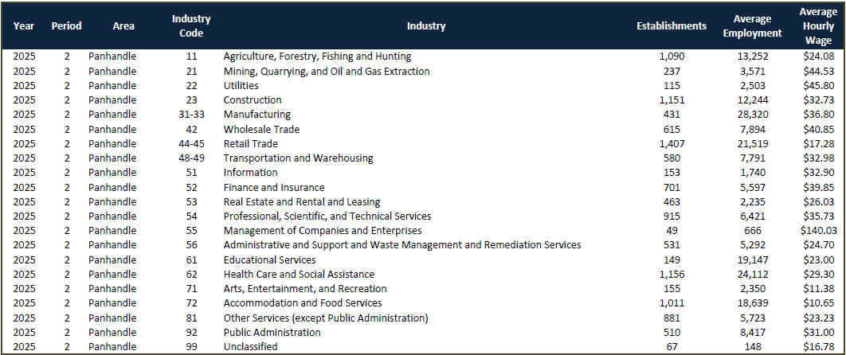
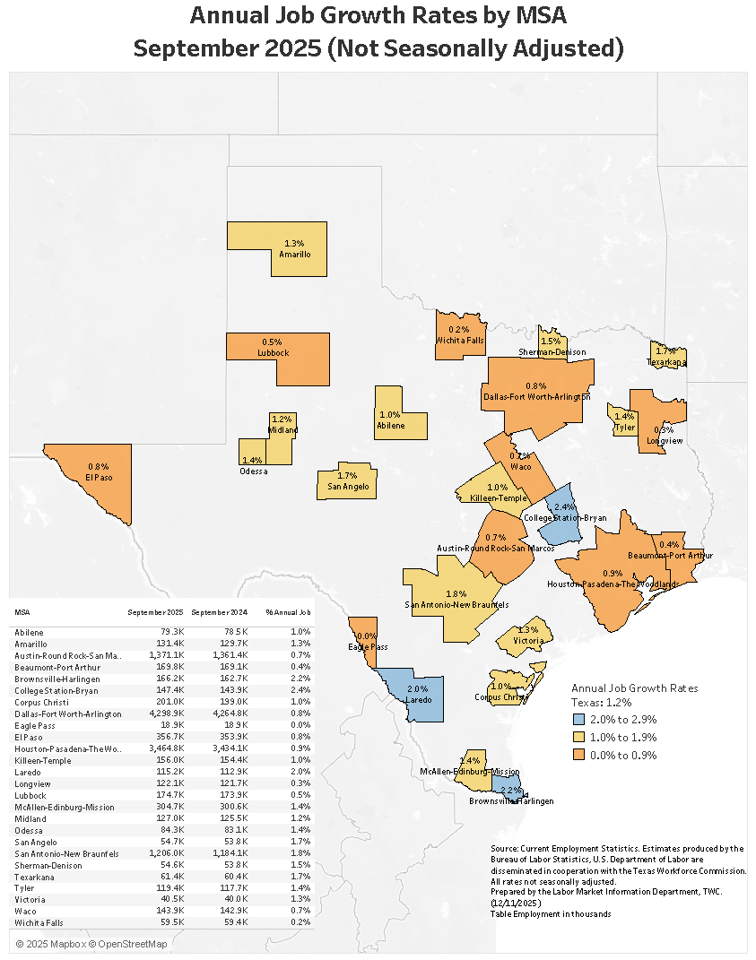

Amarillo MSA Job Growth Rankings
- Unemployment Rate Ranking: Amarillo tied with Midland for 1st place at 3.3% among Texas MSAs, ahead of San Angelo (3.4%) and Abilene College Station-Bryan & Lubbock (3.7%).
- Monthly Job Growth Ranking: Amarillo ranks 4th with a 0.5 % change (600 jobs), a significant improvement from August, suggesting a strong recovery.
- Annual Job Growth Ranking: Amarillo ranks 11th with a 1.3% growth rate, adding 1,700 jobs, surpassing the Texas average of 1.2%.
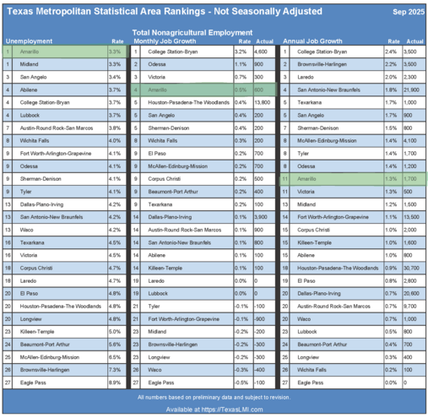

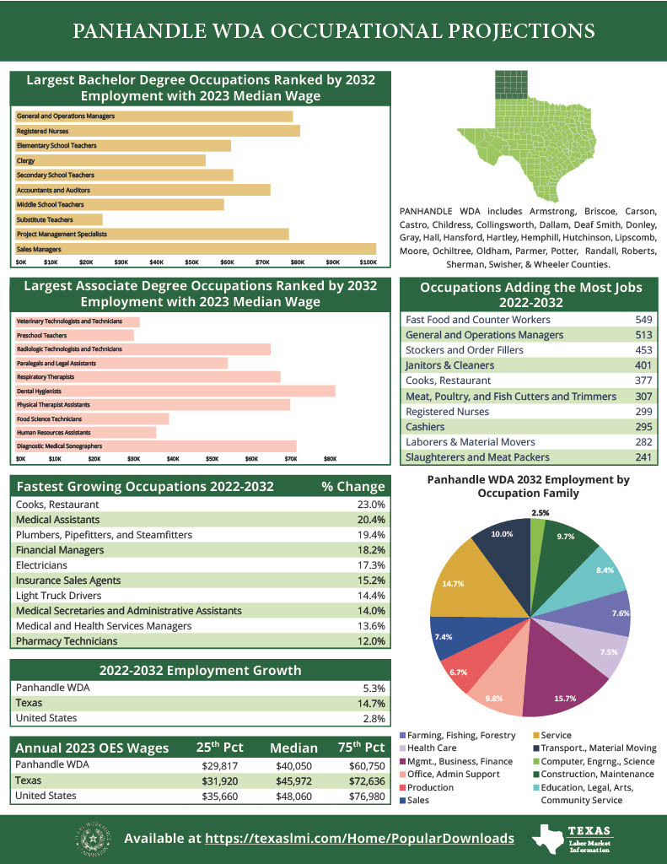
Skilled Labor Pipeline and Training Capacity
Primary training partners in the region:
- Amarillo College:
  - Programs: Construction Technology/Carpentry, Instrumentation, Electrical, Welding, Engineering (A.S. transfer), Emergency Medical Technician (recent JET grant-supported expansion).
  - Partnerships: Collaborates with Pantex Plant for talent pipelines in engineering and trades; supports apprenticeships and high school dual credit via AmTech Career Academy.
- West Texas A&M University (Canyon):
  - Programs: B.S. in Civil Engineering, Mechanical Engineering, Electrical Engineering, Environmental Engineering, Engineering Technology.
  - Focus: Prepares graduates for engineering roles in large-scale projects.
- Other Regional Providers:
  - Frank Phillips College and Clarendon College: Vocational nursing and allied health, with potential for trade expansions.
  - Pantex Plant proximity provides experienced workforce in high-security, precision manufacturing and trades.
Workforce Solutions Panhandle Services:
- Skills Development Fund grants for customized employer training.
- Skills for Small Business program for upskilling new/incumbent workers.
- Job Training Services: Funding for targeted occupations, including skilled trades.
- Recruitment support: Job fairs, candidate screening, WorkInTexas.com postings.
- Apprenticeship coordination and work-based learning.

Workforce Solutions Panhandle
Business Services Unit
3120 Eddie, Amarillo, TX 79106
(806) 345-1341
www.wspanhandle.com

