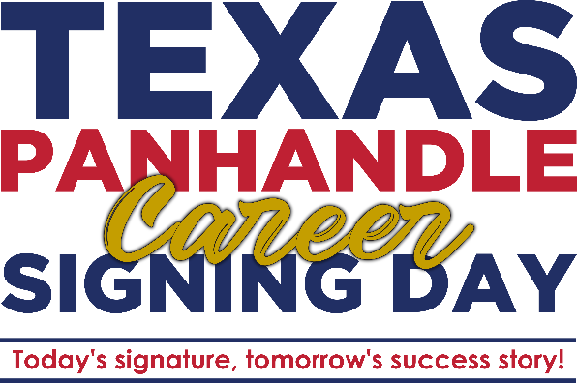

XXXX High School
Career Signing Day

XXXX XX, 2026
XX:XX PM

Opening Remarks
Phillip Flores with Workforce Solutions Panhandle

Speakers:
XXXX, Principal of XXXX High School
XXXX CTE Instructor of XXXX High School
XXXX CTE Instructor of XXXX High School
Signing of the Career Signing Day Certificates
Closing Remarks by XXXX

